

Technical Documentation

Svm Dr - Install Module

nov 2018

*Number of pages : 5*

*Version : 1.0.0*

# Document Information

## Revision History

|  |  |  |  |  |
| --- | --- | --- | --- | --- |
| Date | Version | Status | Prepared by | Comments |
| 2018/11/14 | 1.0 | Draft | WFA | Initial Draft |
|  |  |  |  |  |
|  |  |  |  |  |
|  |  |  |  |  |

## Document Control

|  |  |  |  |
| --- | --- | --- | --- |
| Role | Name | E-mail | Telephone |
|  |  |  |  |
|  |  |  |  |
|  |  |  |  |

## Approval

|  |  |  |  |
| --- | --- | --- | --- |
| Role | Name | Signature | Sign-off Date |
|  |  |  |  |
|  |  |  |  |
|  |  |  |  |
|  |  |  |  |

## Table of Contents

Svm Dr - Install Module 1

nov 2018 1

*Number of pages : 5* 1

*Version : 1.0.0* 1

Document Information 2

Revision History 2

Document Control 2

Approval 2

Table of Contents 3

1 Introduction 4

1.1 Purpose 4

1.2 Description 4

1.3 Assumptions 4

2 Workflow Inputs and outputs 4

2.1 Screenshot 4

2.2 Workflow inputs 4

2.3 Workflow outputs 4

3 Workflow operation 4

3.1 Workflow commands 4

3.2 Commands usage 5

3.2.1 Powershell commands 5

3.2.2 CLI commands 5

4 Apendix 5

4.1 Circulation list 5

4.2 Workflow versions 5

# Introduction

## Purpose

This document defines the operation of the workflow, input parameters and performed tasks.

## Description

The workflow copies or removes Svm Dr Module.

## Assumptions

For individuals reading this document please note that the following has been assumed:

* A familiarity with NetApp products and technologies
* WFA configuration and NAS system configuration meets requisites and configuration defined in the documents "Storage Engineering WFA Standards" and "Storage Engineering WFA NAS Provisioning and amendments Standards"

# Workflow Inputs and outputs

## Screenshot

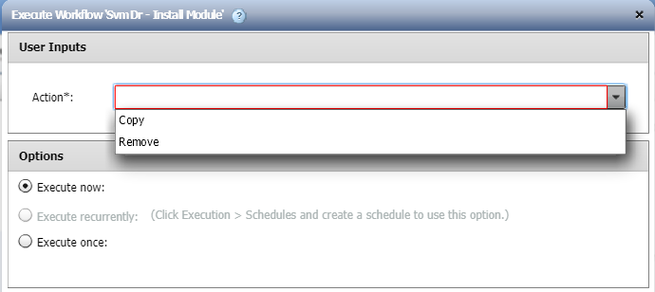

## Workflow inputs

The table below shows the general workflow inputs.

|  |  |  |  |
| --- | --- | --- | --- |
| Name | Type | Description | Notes |
| Action | Enum |  | Mandatory. |
| Destination Path | String | Wrap the path in quotes, this avoids escaping the backslash character. | Mandatory. |

## Workflow outputs

None.

# Workflow operation

## Workflow commands

The table below shows the commands used in the workflow.

Not all the commands may run in every execution. There are conditionals that may disable a set of commands if conditions are met.

|  |  |  |
| --- | --- | --- |
| Name | Base command | Description |
| Manage Svm Dr Module | Manage copy of module Svm Dr Module / 1.0.0 | Copy or Remove 'Svm Dr Module' into WFA's PoSH module path |

# Apendix

## Workflow versions

|  |  |
| --- | --- |
|  |  |
|  |  |
|  |  |
|  |  |
|  |  |